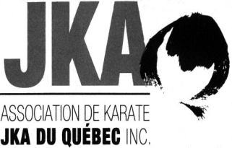 | AKJKAQ Summer Training Camp  June 22 to 26, 2022  www.akjkaq.ca
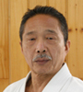 | Guest instructor:  Sensei Imura Takenori  8th Dan, Japan  at the Palestre of the École de technologie supérieure, Building B, 1111, Notre-Dame West, Montreal (corner Peel). From ground level, take elevator to third floor.
SCHEDULE
Wednesday |  | 9h30 à 10h30 | All
June 22, 2022 |  | 10h30 à 11h00 | Black belts Katas (Tekki Nidan, Sochin)
 |  | 16h00 à 17h30 | All
Thursday |  | 9h30 à 10h30 | All
June 23, 2022 |  | 10h30 à 11h00 | Blacks belts Katas (Tekki Sandan, Nijushiho)
 |  | 16h00 à 17h30 | All
Friday |  | 9h30 à 10h30 | All
June 24, 2022 |  | 10h30 à 11h00 | Black belts Katas (Hangetsu, Jitte)
 |  | 16h00 à 17h30 | All
Saturday |  | 9h30 à 10h30 | All
June 25, 2022 |  | 10h30 à 11h00 | Black belts Katas (Kanku Sho, Bassai Sho)
 |  | 16h00 à 17h30 | All
 |  | 19h00 à 22h00 | Party
Sunday |  | 9h30 à 10h30 | All
June 26, 2022 |  | 10h30 à 11h00 | Black belts Katas (Chinte, Gojushio Sho)
 |  | 11h00 à 12h30 | Dan examinations
Rules regarding the use of cameras, videos, cellulars, etc. during AKJKAQ activities.

It is strictly forbidden to photograph, film or take pictures with any device without permission from AKJKAQ.

For more information, please contact Jean-Pierre Cusson by email karate.jka@videotron.ca or at 450 441-1061.

